Depth First Search (DFS)

Aim
To implement the Depth First Search (DFS) algorithm in Python to traverse all the nodes of a graph by exploring as far as possible along each branch before backtracking.

Objectives
- To understand the concept of graph traversal.
- To implement DFS using Python.
- To use a stack/recursion for DFS traversal.
- To visit each node systematically.
- To display the DFS traversal of the given graph.

Algorithm
- Start from the given starting node.
- Mark the starting node as visited.
- Display the current node.
- Visit an unvisited adjacent node.
- Mark the adjacent node as visited.
- Repeat the process recursively until there are no unvisited adjacent nodes.
- Backtrack to the previous node.
- Continue until all reachable nodes are visited.
- Stop the process.
Flow Chart:
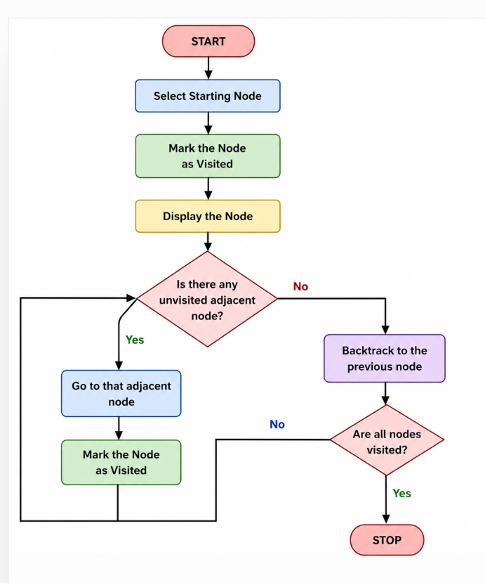
Code:
def dfs(graph, node, visited):
if node not in visited:
print(node, end=" ")
visited.add(node)

for neighbor in graph[node]:
dfs(graph, neighbor, visited)

graph = {
'A': ['B', 'C'],
'B': ['D', 'E'],
'C': ['F'],
'D': [],
'E': ['F'],
'F': []
}

visited = set()

print("DFS Traversal:")
dfs(graph, 'A', visited)
Output:
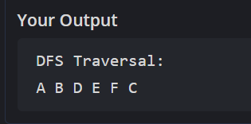
Result:
Thus, the Depth First Search (DFS) algorithm was successfully implemented in Python, and the given graph was traversed by exploring each branch deeply before backtracking.

